Moon Viewing Festival (Otsukimi お月見)
Lesson Plan

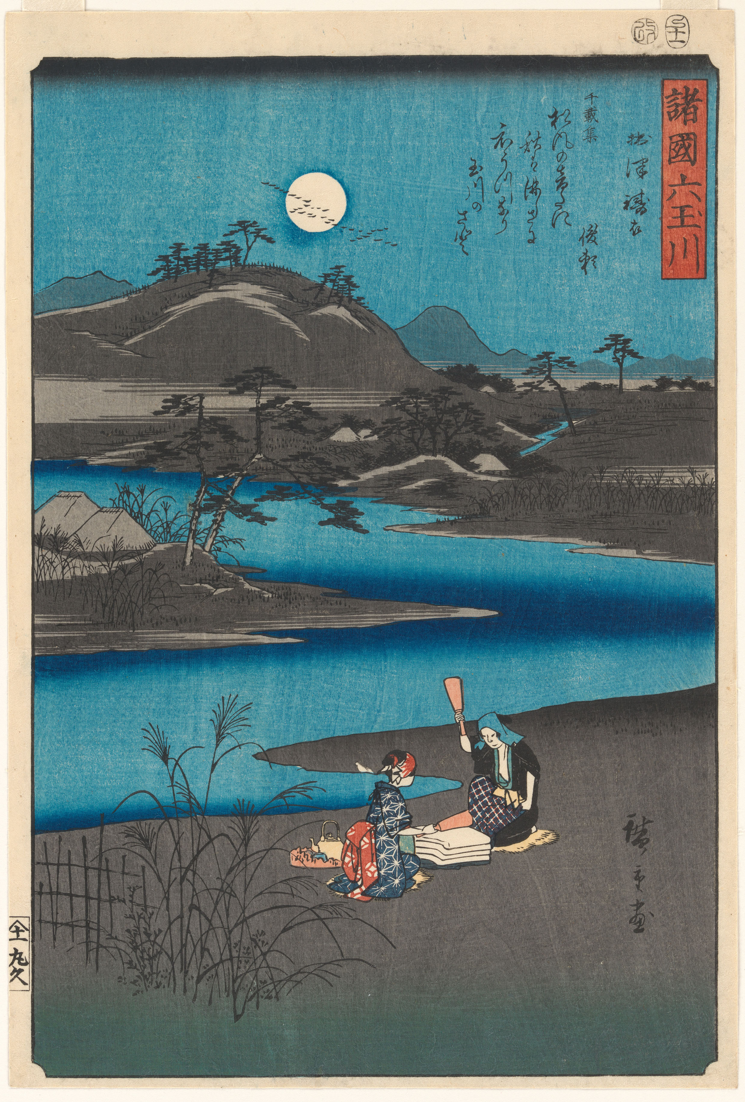
Utagawa Hiroshige

One of Six Jewel River Views from Various Provinces 1857
Collection Metropolitan Museum of Art
https://www.metmuseum.org/art/collection/search/53449

Moon Viewing Festival (Otsukimi お月見)
Lesson Plan

Designed by Eve Eisenstadt, Ed.D.
Dr. Eisenstadt is the district arts coordinator for Scarsdale Schools, NY.
She also teaches Japanese Art History at Parsons School of Design, NY.
This lesson was created in November of 2020
for the Hammond Museum and Japanese Stroll Garden
with generous funding from Japan Foundation Center for Global Partnership.
in November, 2020.

Resources:

• Hammond Museum videos for Virtual Moon Viewing (Otsukimi) and Sky Viewing
• Watercolor technique video: https://www.youtube.com/watch?v=m4Opm8LMAk8
• Slideshow of images relating to the Moon Viewing Festival (Otsukimi)
• Slideshow of images relating to the story of Orihime and Hikiboshi
• Background material for teachers (to be read prior to lesson)

Introduction and Teaching point:

To make a watercolor painting illustrating either the Moon Viewing Festival (Otsukimi) or the story of Orihime and Hikiboshi

This lesson will take a minimum of two double periods.

Lesson Content:

Teaching:
Students will view the above videos, slide shows, and discuss the fundamentals of the Moon Viewing Festival (Otsukimi) and the story of Orihime and Hikoboshi.
Students will create their own illustration. They will have a choice of basing it upon images they have seen of the Moon Festival or the story of Orihime and Hikoboshi.
Active Involvement:
Discussion
During and after the reading of the story, viewing of the video and slide show, students will engage in discussion guided by teacher questions.
Examples of some questions:
• Why do you think the moon is so important to Japanese culture?
• In the West we see a man in the moon, in Japan it is a rabbit pounding mochi. What do these two different views of what is on the moon relate to each culture? Why a man in the West and a rabbit in Japan?
• Looking at the Japanese prints, how is the story depicted? Notice how the artists use space, color, line, perspective. How are these used differently in the Japanese prints than they are in the West? How are the elements and principles of art used to create the Japanese woodblock aesthetically appealing? How would you describe this aesthetic?
What is the story of Orihime and Hikoboshi meant to teach the listener?
Why is the story set in the sky?

Art Activity:

The teacher demonstrates the use of watercolors. Students will be asked to create an illustration of the Moon Viewing (Otsukimi) or of a scene from the story of Orihime and Hikoboshi. They can incorporate contemporary images into their work. For example, guests may be shown viewing the moon from the top of a high rise. They should include their own personal vision of what moon-viewing means to them.
The students will be asked to incorporate some of the principles they learned from examining and discussing the Japanese prints. These include: use of outline, flattening space, flattened color, cropping, viewpoint from above, etc.
Each student will write, perhaps in conjunction with the English teacher, a short poem to accompany their illustration.

Assessment:

The class will display the illustrations and poems together. They will have a critique with the teacher discussing all aspects of the project. Example questions for the critique:
• How is the Japanese aesthetic used in your piece?
• Why did you depict the scene and the location as you did?
• What makes this personal to you?
• Which watercolor techniques to you employ to create your vision?
• What did you learn about Japan through this experience?

Links:

• How does the Moon Festival connect to festivals in your culture?
• How does the myth of Orihime and Hikoboshi connect with the myths of other cultures?
• A visit to a museum to view Japanese prints and illustrations.

Purpose of this lesson:

To understand Japanese culture better through the Moon Viewing Festival (Otsukimi) and the story of Orihime and Hikoboshi.
To observe imagery of the Moon Viewing Festival (Otsukimi) and understand Japanese aesthetics involved in this work.
To create a personal work based on looking at the moon and how the student represents cultural concepts associated with the Moon Viewing Festival (Otsukimi) or the story of Orihime and Hikoboshi.

Supplemental Material:

The Moon Viewing Festival (Otsukimi) came to Japan from China about 1000 years ago. It began in China during the Tang dynasty (618-907). Japanese aristocrats enjoyed moon-viewing parties during the Nara (710-794) and Heian (794-1185) periods. They played music and composed poetry about the moon. During the Edo period (1603-1868), moon-viewing was a popular practice among commoners as well. Traditionally, in accordance with Shinto beliefs, Japanese express thanks to the moon for a good harvest.

The celebration takes place on the 15th day of the 8th month in the Japanese traditional/lunar calendar. During the festival people make offerings to the moon gods, to celebrate the harvest; family and friends gather to view the moon at windows and on verandas. Often a tea ceremony and koto (Japanese zither) concert accompany the moon-viewing as part of the festivities. Special floral arrangements (ikebana) associated with the tea ceremony are also put on view.

• Tsukimi-dango are round rice dumplings that represent the full moon. Eating the dumplings is said to bring health and happiness. The dumplings are displayed on the veranda or by a window. There are different traditions for displaying the dumplings: one calls for a display of 15 dumplings for the 15th night of the calendar, another specifies a display of 12 dumplings, one for each month of the year.

• Susuki: Several plumes of pampas grass are arrayed to represent a bountiful harvest of rice. The pampas grass looks like rice plants.

• Taro: Taro bulbs have several shoots and are associated with a large and successful family.

The Rabbit in the Moon

In the West we speak of the Man in the Moon. In Japan, the image seen on the moon is one of a rabbit pounding mochi, a special rice, with a large mallet to make holiday rice cakes. The image may derive from a Buddhist tale.

Orihime and Hikoboshi: Orihime, a princess and the daughter of Tentei (the Sky King), wove beautiful cloth by the banks of the Amanogawa (Heavenly River, or Milky Way as it is known in the West). She wove constantly to please her father because he loved the cloth she wove. However, Orihime was sad. She worked so hard, she had no time to meet any other people. Tentei worried about his lonely daughter; he wanted her to find love.

It came to pass that he arranged for her to meet Hikoboshi, a cow herder, who worked and lived on the other side of Amanogawa. They met and fell instantly in love. They were so in love that Orihime stopped weaving and Hikoboshi ceased to look after his cows. Tentei grew angry at this. He separated the lovers, transporting them to opposite sides of the Amanogwa and forbade them to see each other ever again.

Depressed by this, Orihime begged her father to allow her to reunite with her love, Hikoboshi. Tentei agreed to let them meet, but only once a year, and only if she finished her weaving. When she accomplishes this, he allows the young lovers to meet on the 7th day of the 7th month. On that day, Orihime takes a boat across the Amanogawa to meet Hikoboshi – unless it rains. If it rains the boat cannot sail, but a flock of magpies form a bridge so she can cross the river stepping lightly on their wings.

In the night sky, the star Vega represents Orihime and the star Altair represents Hikoboshi. The lovers often appear against a starry background, or by a river. Although the story of Orihime and Hikoboshi is connected to the Tanabata Star Festival in mid-July many people associate it with the Moon Festival, too. The story and festival came to Japan from China.

