Ceramic Teal Bowls

Lesson Plan

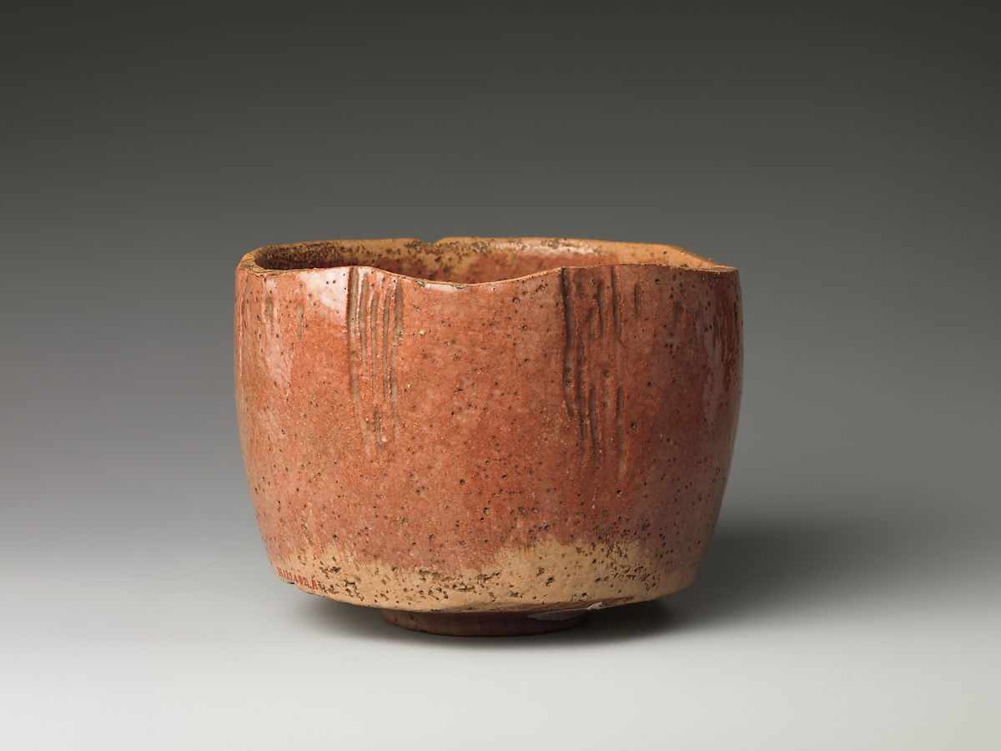
Red Raku Tea Bowl
(copy of the Kaga Kōetsu Tea Bow 18th century)
Collection Metropolitan Museum of Art
https://www.metmuseum.org/art/collection/search/63148

Ceramic Tea Bowls

Lesson Plan

Designed by Eve Eisenstadt, Ed.D.
Dr. Eisenstadt is the district arts coordinator for Scarsdale Schools, NY.
She also teaches Japanese Art History at Parsons School of Design, NY.
This lesson was created in November of 2020
for the Hammond Museum and Japanese Stroll Garden
with generous funding from Japan Foundation Center for Global Partnership.
in November, 2020.

Resources:

• Hammond Museum Video on the Tea Ceremony
• Ceramic tea bowls for the Tea Ceremony
https://www.metmuseum.org/toah/hd/jtea/hd_jtea.htm
• Wabi-Sabi
https://www.youtube.com/watch/?v=QmHLYhxYVjA&app=desktop
• Video on the coil and pinch method
https://www.youtube.com/watch?v=th8yLtFjZ58
• Slideshow of Japanese Tea Bowls
(see attachment)

Materials:

Kiln, clay, glaze, brush, fork, needle tool, rib

Teaching point:

To make a Japanese-style tea bowl

Lesson Content:

This lesson is connected to the Japanese Tea Ceremony and the utensils used during the ceremony, in particular the tea bowl. The purpose of this lesson is to make a tea bowl focusing on the aesthetics found in the philosophy of wabi-sabi.

The tea ceremony originated in China as part of Buddhist practice came with Buddhism to Japan. (see above videos). The concept of wabi-sabi is Japanese.
Wabi means rustic simplicity or understated elegance. Sabi is the beauty of the imperfect. Wabi-sabi derives from nature and the observance of the natural world; the beauty to be found in nature. It celebrates the imperfect and the transient, the irregular and the asymmetrical. Nothing is permanent. There is beauty in aging, in the crack that forms in a pot, in the patina of use. (See images of tea bowls in the web page from the Metropolitan Museum of Art and the accompanying slide show.

When creating a tea bowl (chawan) the potter wants to make the bowl light enough to handle with ease yet heavy enough that the holder of the bowl feels the presence in their hand. Not too thin or the bowl will lose heat but not so thick that the hand does not feel the warmth of the tea.

The rim should be smooth so that it does not hurt the lip during drinking and also to make it easy to wipe clean. The interior should be uniform, no rough areas, so that the whisk is not damaged when the tea is mixed. The foot should accommodate the fingers of the host who will hold it between the thumb and fingers of one hand.

The tea bowl will be made by the coil or pinch pot method. This allows for more control in creating an asymmetrical and irregular shape, as in nature. (Please see suggested video on technique listed in resources above)

As students are creating their bowls they should experiment with different textures on the outside surface and can even press and distort objects from nature into the clay. Keeping in mind the wabi sabi concepts of use, patina, and wear as they works. Once the bowl is fired the glaze color and technique should also reflect wabi sabi.

Connection:

This lesson connects to the Japanese Tea Ceremony and an understanding of Japanese aesthetics. It also enables students to discuss the nature of beauty and how various cultures view beauty differently.

Introduction and Teaching Point:

Students will view with the teacher the video from the Hammond Museum on the Ryu Sui Kai Tea Ceremony. They will also view the video on Wabi Sabi, provided above. The teacher will use the Metropolitan Museum link, also provided above, to begin discussion on Japanese tea bowls as well as to show images of the bowls. The slide show created (Please see above) will further the aesthetic discussion.

Through class discussion students will comprehend the concepts they will embrace while making their own tea bowls.

Sample questions for viewing images of tea bowls:
• How does the bowl utilize asymmetrical form?
• Can you see the process of making the bowl? Evidence of fingerprints and trails where the clay was pushed in and out?
• How does the bowl reflect nature and the principles of wabi-sabi?
• Does the glaze enhance the bowl and if so how? Are there patterns, symbols, brushwork?
• Is there more than one color of glaze? Do they overlap?
• How do you think the glaze was applied?
• Does the glaze support the principles of wabi-sabi?

After viewing the slides and discussion of the tea ceremony and wabi-sabi, students should ask themselves questions as they create their bowls. (If the teacher is unfamiliar with coil and pinch technique please review the video under resources that explains these techniques) Some suggestions are:

• Is my bowl asymmetrical yet functional?
• Does it adhere to the principles of wabi-sabi?
• Do the lip, interior, and foot, achieve the criteria listed above for making a chawan?
• What forms of nature inspired my bowl?
• Does the glaze enhance and work in harmony with the form of my tea bowl?

The teacher will also demonstrate the coil and pinch methods of making pots. The teacher will demonstrate glazing techniques, such as pour and brush.

This lesson will take a minimum of two double periods in the classroom and one half-day field trip to the Hammond Museum and Japanese Stroll Garden.

Active Involvement:

There should be discussion and Q&A during all aspects of the lesson.

As students create their bowls there should be continued discussion and class critiques on how students are embodying the concepts yet engaging their imaginations to create bowls uniquely their own. How do the bowls reflect something personal about the students, and how they understand the aesthetic that they are exploring?
Clay is malleable so it can be altered during the making. Therefore, it is important to have a discussion as work progresses, in order to determine if the bowls are embodying the principles of wabi-sabi.

Product/Assessment:

Students will share and critique their bowls with each other when complete. They will discuss if the bowls encompass the concepts of wabi-sabi and the tea ceremony. How did each student accomplish this? Also, are they technically functional? Will the bowl hold water (or tea)? How does it feel in the hand?

Link:

The next step will be to conduct a tea ceremony at the school or with an organization such as the Hammond Museum where students will have the opportunity to use their bowls and discuss the tea ceremony.

